**MYSQL Task**

**create database ecommerce;**

**use ecommerce;**

**create table customers(**

**id int unique primary key auto_increment,**

**name varchar(100),**

**email varchar(100),**

**address varchar(100)**

**);**

**create table orders(**

**id int unique primary key auto_increment,**

**customer_id int,**

**order_date date,**

**total_amount int,**

**foreign key(customer_id) references customers(id)**

**);**

**create table products(**

**id int unique primary key auto_increment,**

**name varchar(100),**

**price decimal(8,2),**

**description varchar(100)**

**);**

**insert into customers(name,email,address) values**

**('Gnanavel','gnanavel@gmail.com','Bengaluru'),**

**('Gopal','gopal@yahoo.com','Namakkal'),**

**('Lavanya','lavanya@outlook.com','Coimbatore'),**

**('Udhaya','udhaya@gmail.com','Chitambaram');**

**select * from customers;**



**insert into products(name,price,description) values**

**('Product A', 50.00, 'Description for Product A'),**

**('Product B', 30.00, 'Description for Product B'),**

**('Product C', 40.00, 'Description for Product C'),**

**('Product D', 60.00, 'Description for Product D');**

**select * from products;**

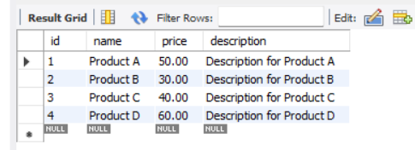

**insert into orders(customer_id,order_date,total_amount) values**

**(1, '2025-02-10', 150.00),**

**(2, '2025-02-20', 120.00),**

**(1, '2025-03-01', 200.00),**

**(3, '2025-03-05', 300.00);**

**select * from orders;**

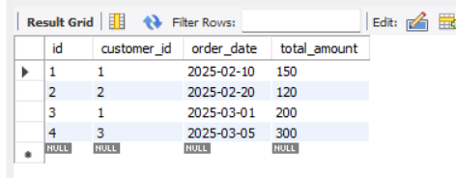

**-- Tasks--**

**-- Update the price of Product C to 45.00.**

update products set price=45.00 where name='Product C';

select * from products;

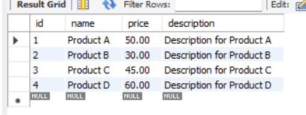

**-- Add a new column discount to the products table**

alter table products add column discount tinyint;

select * from products;

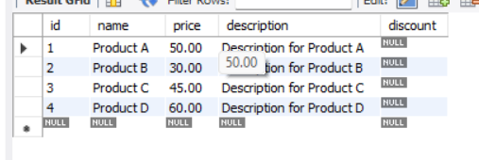

**-- Retrieve the top 3 products with the highest price.**

select name,price from products order by price desc limit 3;

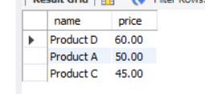

**-- Retrieve the orders with a total amount greater than 150.00.**

select * from orders where total_amount>150.00;

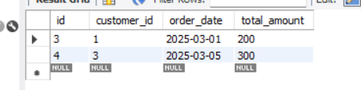

**-- Retrieve the average total of all orders.**

select avg(total_amount) as 'Average Of Orders' from orders;

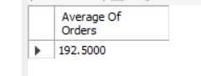

**-- Get the total amount of all orders placed by each customer.**

select name,sum(total_amount) as 'Sum' from customers

join orders on orders.customer_id=customers.id

group by customers.id;



**-- Join the orders and customers tables to retrieve the customer's name and order date for each order.**

select distinct name,order_date from customers

join orders on orders.customer_id=customers.id;



* **--Normalize the database by creating a separate table for order items and updating the orders table to reference the order_items table.**

create table order_items(

id int unique primary key auto_increment,

order_id int,

product_id int,

quantity int,

price decimal(8,2),

foreign key (order_id) references orders(id),

foreign key(product_id) references products(id)

);

insert into order_items(order_id,product_id,quantity,price) values

(1,1,2,300.00),

(2,2,1,120.00),

(1,3,3,150.00),

(3,1,2,200.00);

select * from order_items;

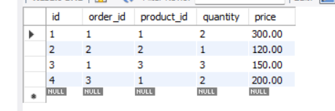

**-- Get the names of customers who have ordered Product A.**

select distinct customers.name from customers

join orders on orders.customer_id=customers.id

join order_items on order_items.order_id=orders.id

join products on products.id=order_items.product_id

where products.name='Product A';

